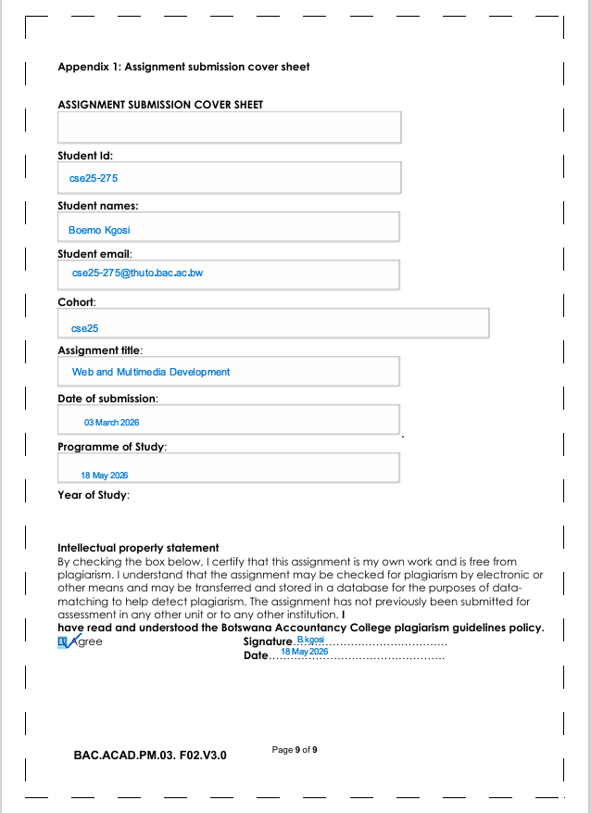

Website planning and Documentation

Website Objective
The website is the main online presence of Kgari Safari which is based in Botswana. It aims to showcase Botswana's beautiful wilderness to attract key international tourists. The main goal is to create a credible website for Kgari Safari with the goal of attracting both international and local tourists, display various Safari packages and also offer a platform where tourists can book through an enquiry.

Botswana Safari tourism market generated a value of USD 2,573.0 million in 2023 and is expected to reach USD 3,948.3 million by 2030 as stated by Grand View Research. A well designed and professional website gives Kgari Safari an opportunity to capture this growing and meaningful tourism market.

Botswana has a reputation of a world class Safari destination and this increases the business case for the website for Kgari Safari as Botswana was voted the Best Safari Country for the fourth time by Safaribookings.com.

The Okavango Delta is a UNESCO World Heritage Site and also Botswana is a leader in biodiversity as 38% of its land is preserved for national parks, reserves and Wildlife Management hence this positions Kgari Safari as a pristine and exclusive Safari experience.

W3C (World Wide Web Consortium) Standards
The website follows important W3C web standards to ensure compatibility, accessibility, and good web practices.
1. HTML Standards
The website uses proper HTML5 structure including:
- <!DOCTYPE html>
- Header tags
- Navigation lists
- Semantic elements
These improve browser compatibility and readability.
2. Responsive Design
Bootstrap was used to make the website responsive on:
- Mobile phones
- Tablets
- Desktop computers
3. Accessibility
The website improves accessibility through:
- Clear navigation links
- Readable text
- Alternative text for images
- Organized page structure
4. Consistency
The same navigation bar, footer, colours, and layout are used across all pages to maintain consistency.
5. User-Friendly Navigation
Users can move easily between pages through the navigation menu placed at the top of the website.

Target Audience

The website's target audience is mainly international tourists aged between 21-60 from Europe, Asia, North America and Gulf Corporation Council with income above average. Botswana positions itself as a high value, low volume conservation-based tourism and research from Botswana-evisa confirms that the high value Safari segment skews towards affluent, experience driven travelers. European markets including United Kingdom, Germany and France contribute significantly to high value tourism, with visitors typically staying longer and spending more per visit. North American markets, including the United States and Canada, represent important long haul markets that contribute significantly to tourism revenue despite smaller visitor numbers as these visitors typically have higher spending patterns and longer average stays.

The website also aims to attract domestic tourists from Botswana as well as Africa who are interested in tourism as local packages will be included. Users should be comfortable browsing on both desktop and mobile devices.

Type of Website and Content
The website is a promotional(promoting tourism and travel) and information website with a function for contacts and booking forms. It combines multimedia such as professional wildlife photography, destination description with structured information about packages, destinations and company background.
The website contains:
- Tourism information
- Safari package listings
- Destination galleries
- Booking services
- Customer reviews
- Contact information

Information Design and Taxonomy
Site Map

Home(index.html)
-About us
-Safari packages
-Destinations
-Contact Us
-Book Now
Navigation Structure
The website uses a horizontal navigation bar placed at the top of each page.
Navigation links include:
- Home
- Safari Packages
- Destinations
- Contact Us
- Book Now
This structure follows the 3-click rule because users can access important content within three clicks.

Page Template Design
The website uses a modern safari-themed layout with responsive page structures.

Homepage Layout
The homepage contains:
- Header section with logo and navigation
- Hero image slider
- About Us section
- Safari offers section
- Wildlife gallery
- Customer reviews
- Footer section

Design Features
The design includes:
- Large safari images
- Rounded content cards
- Responsive Bootstrap grid layout
- White space between sections
- Consistent navigation and footer
- Nature-inspired colours

Technical Brief

TOOL Purpose
- Html5. Page structured and semantic markup
- Css. Styling, layout
- Bootstrap. Responsive grid,navbar,cards
- JavaScript form validation , interactive elements
- VsCode. Code editor
- GitHub pages. Free web hosting and deployment
- Git. Version control and change tracking
Quality Assurance
The website was tested to ensure compatibility, responsiveness, and proper functionality.
Browser Compatibility Testing
The website was tested on:
Chrome
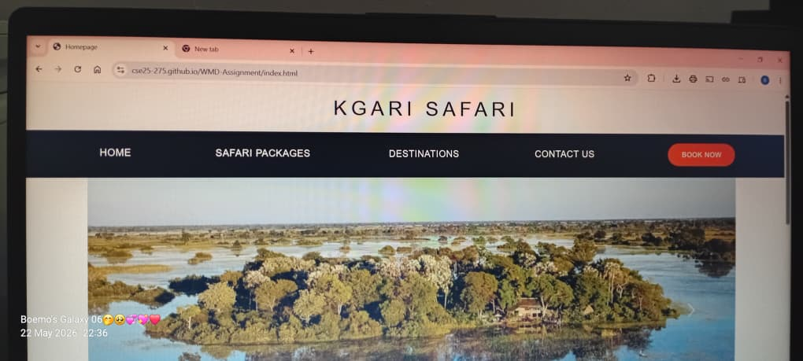
Opera
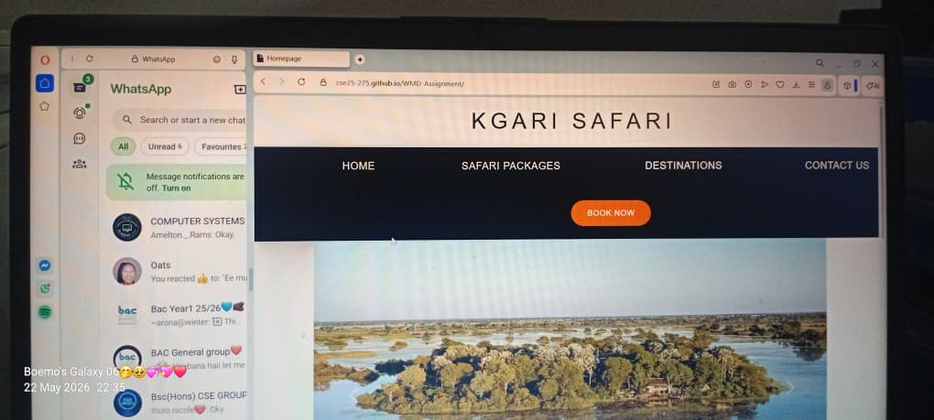
Microsoft edge
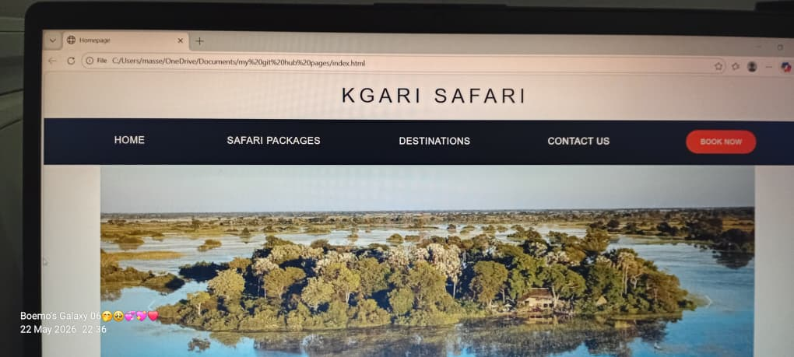

Mobile Device Testing
The website was tested on:
- Android mobile devices
- Tablets
- Desktop screens
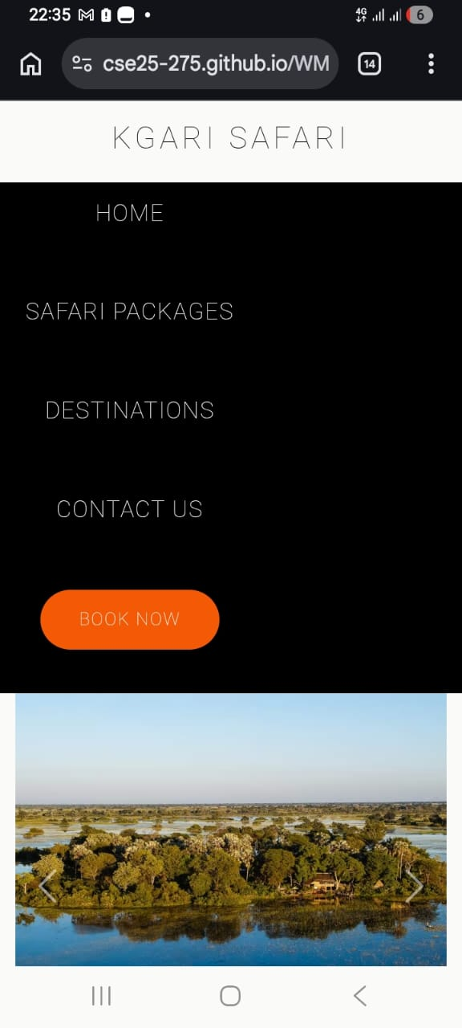
Functional Testing
The following were tested:
- Navigation links
- Image loading
- Carousel slider
- Forms
- Responsive layout
- Footer links
No broken links were identified during testing.

Publishing & Promotion
The website is hosted using GitHub Pages.
Hosting Process
The following tools and methods were used:
- GitHub repository creation
- Git commands
- GitHub Pages hosting

Git Commands Used
git init
git add .
git commit -m "Initial website upload"
git branch -M main
git remote add https://github.com/cse25-275/WMD-Assignment.git
git push -u origin main

GitHub Pages Link
https://cse25-275.github.io/WMD-Assignment/

Future Developments / Recommendations
The following improvements can be added in future:
- Online payment integration
- Live chat support
- User account registration
- Video gallery section
- Search functionality
- Interactive Botswana map
- Multi-language support
- Improved animations and transitions
- Database integration for bookings

